# KidsBlock Software

Note: we take the Windows system as an example. As for MacOS system, just follow this instruction.

1. Double click“KidsBlock 1.0.0 Setup.exe”.

2. Select“**Anyone who uses this computer(all users)**”, then click“**Next**”.

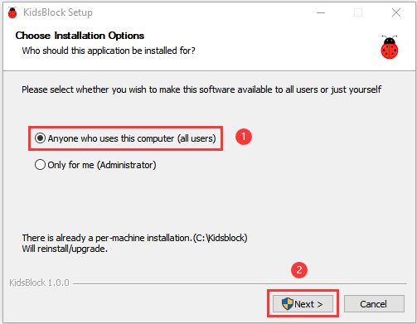

3. Click“**Browse...**”and choose the Disk where the software will be placed (here, we choose C Drive). Then click“**Install**”.

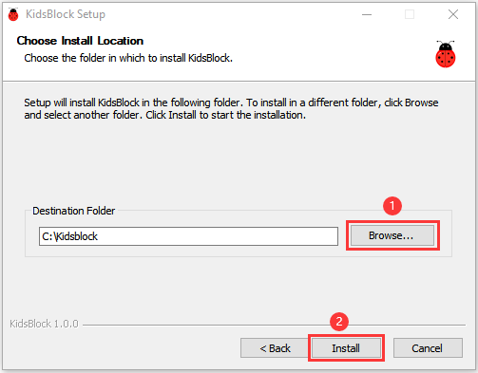

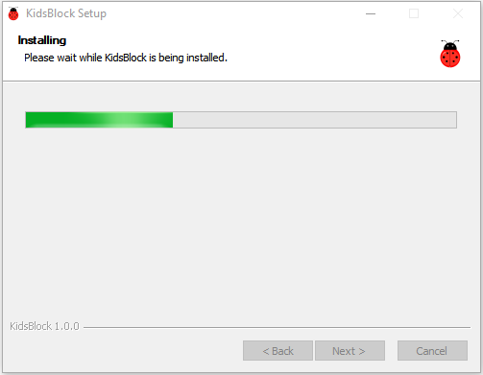

1. After a few seconds, the installation is complete.

Click "Finish" to open the installed Kidsblock software.

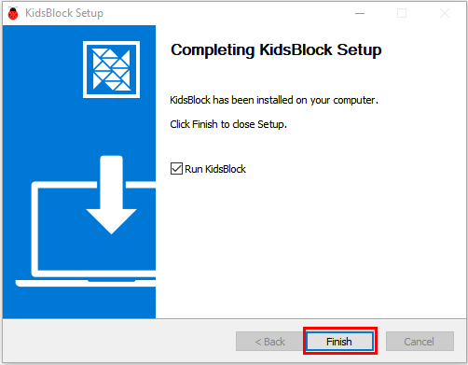

1. If the computer security alert window appears, click on“**Allow access**”.

This is the main page of the Kidsblock software.

